Multi Camera mount (3 cameras 1 Clamp)

Back Side camera bracket
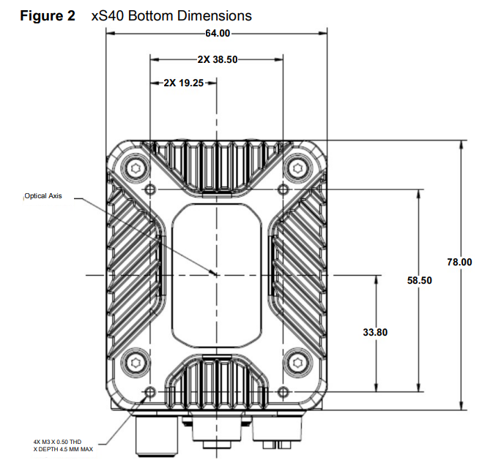

Mounting screws
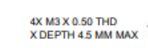
I set the thickness to 4 mm so I can use M3 x 8 mm and a washer.
→

Support Beam
2 x 6 mm screws for each camera → 6 Screws
2 x 6mm washers for each camera → 6 Washers
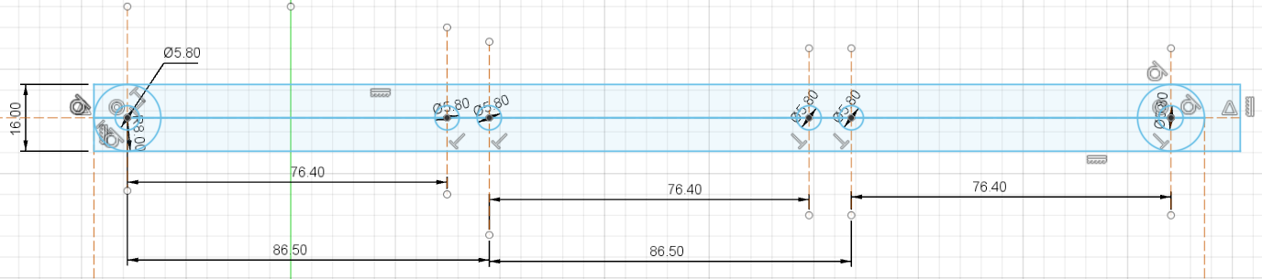

Camera Board

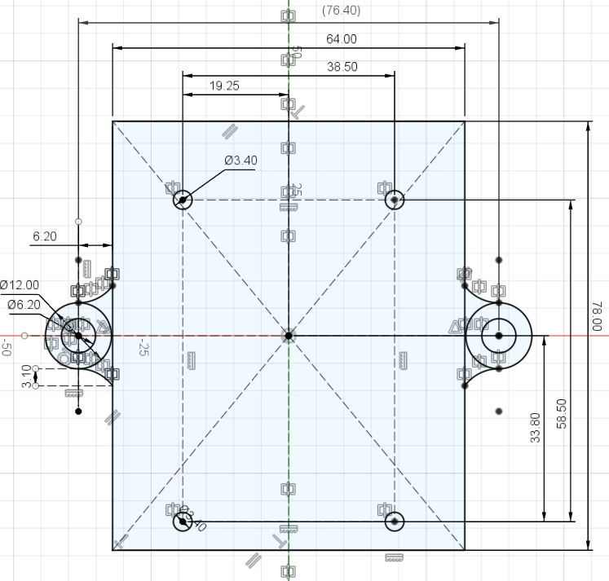

Top view

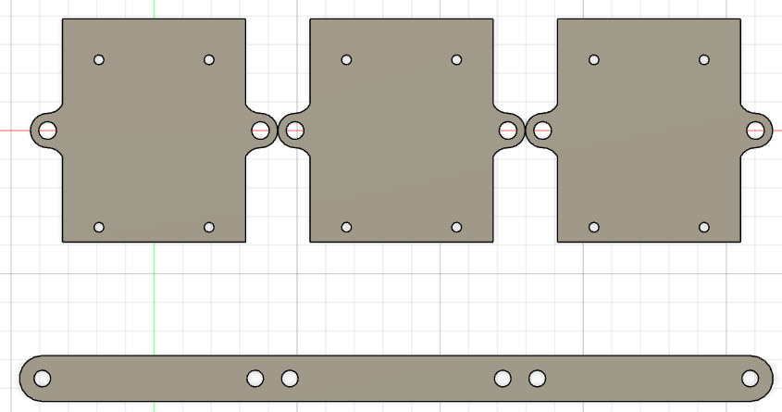

Final result
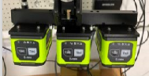 | 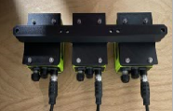 | 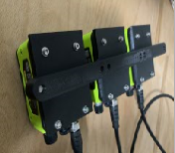

Possible improvements

Camera mount
Since the camera is rounded, so should be the camera mount. Having it squared makes it ugly
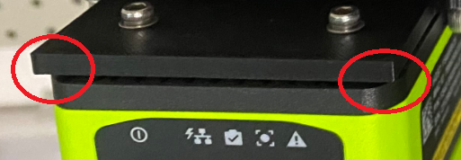

Beam and camera mount joint
The beam is 16 mm wide
The mounting fixture is 12 mm wide, hence this give an impression of mismatching
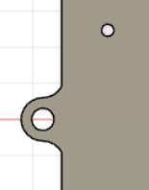 | 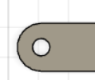 | 